grub.cfg file missing or corrupted in CentOS 7 / RHEL 7

Create an issue
Become root
cd /boot
ll
cd grub2
ll
rm grub.cfg
ll
init 6

grub.cfg file missed or corrupted then getting an error as shown in the image below

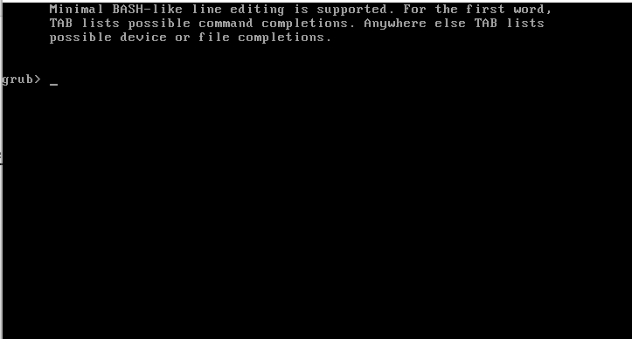

Attach dvd.iso as shown in the image below

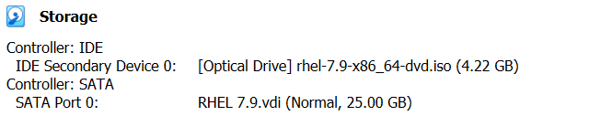

Reset OS through VM
Press Enter on Troubleshooting mode

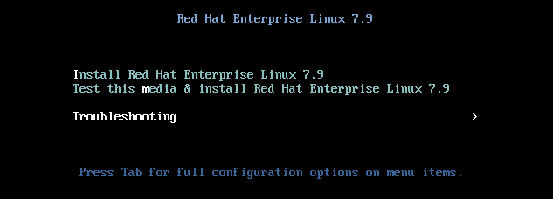

Press Enter on Rescue a Red Hat Enterprise Linux system (Rescue mode)

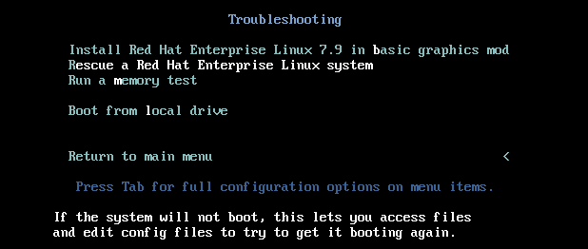

1) Continue 1 Enter

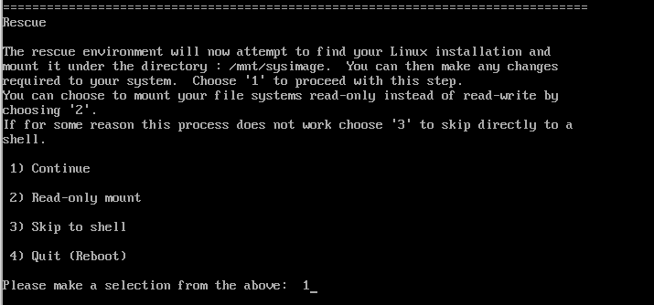

Enter

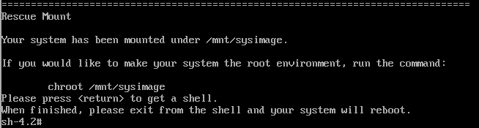

chroot /mnt/sysimage



lsblk

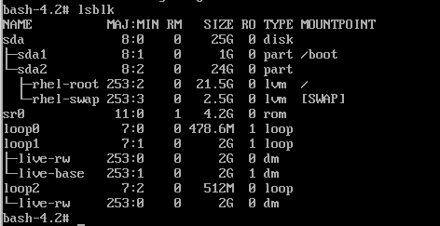

grub2-install /dev/sda

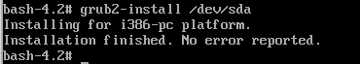

cd /boot/grub2
ls (grub.cfg file not found)

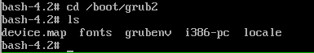

grub2-mkconfig -o /boot/grub2/grub.cfg
ls (grub.cfg file found)

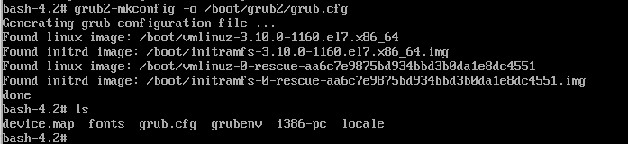

exit



Remove dvd.iso as shown in the image below



Reset OS through VM
The system is started booting up without any issue

